US Airways Flight 1549. Lion Air Flight 610, and Ethiopian Airlines Flight 302. Oceanic Airlines Flight 815. Unlike the names of the nearly 100,000 flights that take off on a normal day, pre-COVID-19, these ones might ring a bell due to their (in)famous nature. Those would be Captain Sully's Miracle on the Hudson, the two fatal flights that grounded the Boeing 737-MAX, and the flight from LOST, respectively.

With such well-publicized incidents, both fatal, fictional, or miraculous, you might get the impression that these days, you are taking your life into your own hands every time you risk flying rather than driving, boating, or even walking! After all, you might say, hopping into a metal tube cruising at 583 MPH at 35,000 feet is just asking for trouble!

This could not be farther from the truth! For many years now air travel has been one of the safest modes of transportation available! The airline industry has been totally committed to safety for decades, and in the United States in particular has operated at an unprecedented level of safety. “During the past 20 years, commercial aviation fatalities in the U.S. have decreased by 95 percent as measured by fatalities per 100 million passengers.”, Federal Aviation Authority.

We can look at the raw numbers to see this for ourselves. Figure A compares the incidents and fatal incidents over two time periods, the 1985-1999 time period and the 2000-2014 time period. As you can see, not only has the number of incidents declined 57% over the two time periods, but 30% of incidents were fatal in the first time frame compared to 16% in the second. Not only are you *less likely* to be involved in an incident these days, being in an incident is far less likely to be fatal than it was previously.

*Figure A*

You might be asking yourself, sure, it looks like I’m less likely to be injured, but I’m going to be sticking to driving. At least then, I’m in control of the vehicle and it will just take us longer to get there. The fact is, nearly 38,000 people died in car crashes in 2016 alone[1] versus the 18,627 people that died because of aircraft-related incidents from 1995 – 2008. This next chart illustrates this:

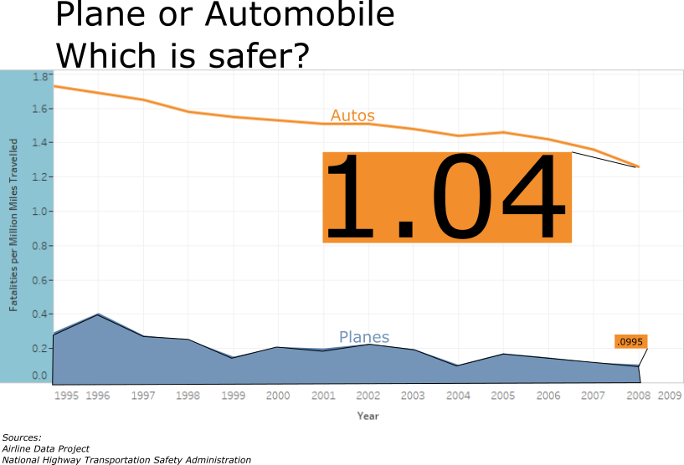

*Figure B: Automobiles Versus Airplanes*

As you can see, per 100 million miles travelled, travelling by car can be far more dangerous than travelling by airplane. In 2008, the most recent year available in our dataset, you were 12.66 times more likely to die travelling by car than by airplane. Until we have self-driving cars, this trend will likely continue (and even then, who is to say that self-driving technology will not be integrated into aircraft systems as well, further plummeting the incident rate for the airline industry?)

In today’s 24/7 news cycle, big incidents steal a lot of press time. In addition, reporting of incidents has become mandatory and the fact is that we have a lot more data at our fingertips then we used to. In years past, a plane crash in Asia might make a blip in the world news section of your local paper unless a hometown hero was involved. But now, it will be front page news across the internet. That is not necessarily a bad thing, but it is important to have some perspective.

Looking at the underlying data, it is clear to see that air travel is safer than it has ever been, especially compared to the alternatives. So if you are worried about travelling by air, relax! Put your tray table up, return your seat to its full upright locked position and we will see you at 35,000 feet!

*Automobile data courtesy of the National Highway Transportation Safety Administration. (*<https://www-fars.nhtsa.dot.gov/Main/index.aspx>) *Plane incident information courtesy of the Aviation Safety Network (*<https://aviation-safety.net/>). *Annual flight miles courtesy of* <http://web.mit.edu/airlinedata/www/Traffic&Capacity.html>. *Plane fatalities per year courtesy of Kaggle.com (*<https://data.world/hhaveliw/airplane-crashes-1908-2009>)

1. National Highway Traffic Safety Administration, February 2018